Yelena’s Gallery  Friday Night Concert Series  December 6 & 20*, 2104 7:30 PM  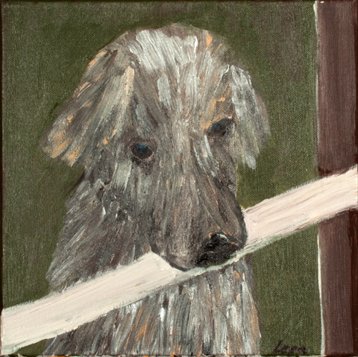  *repeated program  Yelena’s Gallery  2 Archbridge Lane, Springfield, NJ  Tel: (917)-981-0154; Tel: (973)-953-9093 | Farewells  Fleur Barron – Mezzo Soprano  Miriam Leskis – Piano  Missed Connections and Second Chances  R. Schumann  Tragodie i and II (Tragedy)  Der Schwere Abend (The Oppresive Evening)  Mein Wagen rollet Langsam (My Cart Rolls slowly)  Es leuchtet Meine Liebe (My love laughs)  Still Liebe (Silent Love)  J. Brahms  Vergebliches Staendchen (A futile Serenade)  Der Jaeger (The Hunter)  Gana zum Liebchen (The Way to he Beloved)  Auf dem Kirchhofe (At the church Graveyard)  Sapphishce Ode (A Sapphic Ode)  Des Liebsten Schwur (The Lover’s Oath)  F. Schubert  Sehnsucht (Longing)  Im Fruhling (In the Spring)  Der Wanderer (The Wanderer)  Der Tod und Das Madchen (Death and the Maiden)  Suleika

